1. What is kubernetes ?

* 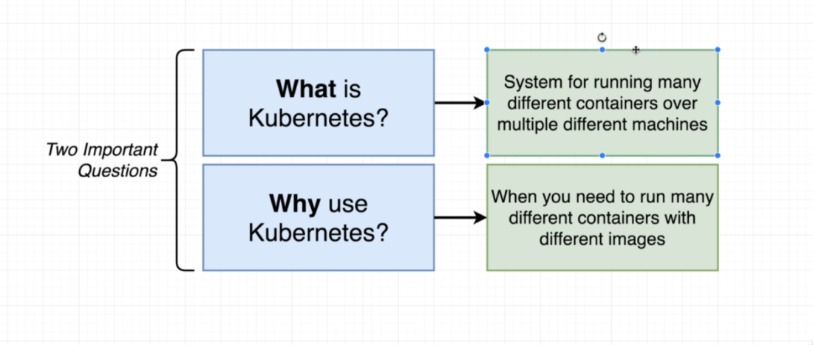
* Kubernetes is tool that provides container orchestration. It helps to run multiple containers, in different numbers, across multiple machines.
* Kubernetes is best solution when we have multiple different types of containers.
* If we need to scale only a single type of container(one single app), then kubernetes is not the best solution available.
* Kubernetes is a platform for managing containers. It runs and manages multiple containers across the virtual machines.

1. **Working with Kubernetes?**

1. Architecture:

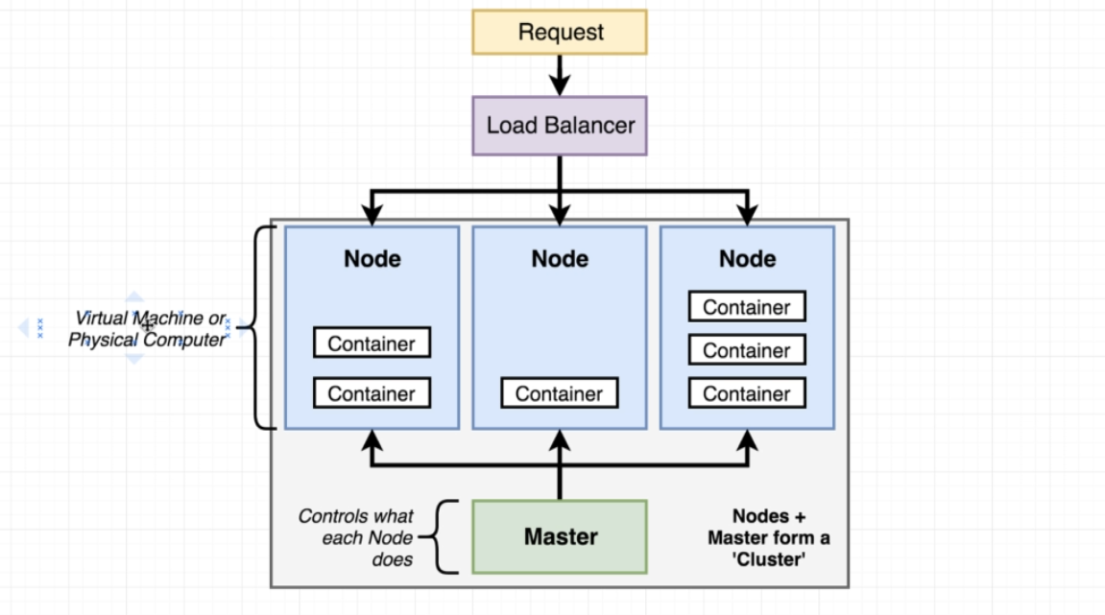

* Kubernetes architecture has a cluster having one master node and multiple worker nodes.
* A node can be a virtual machine or a physical computer to run some number of different containers
* Master nodes controls the worker nodes and the containers running on them.
* As developers, we send our commands to the master and master will perform them on the worker nodes.

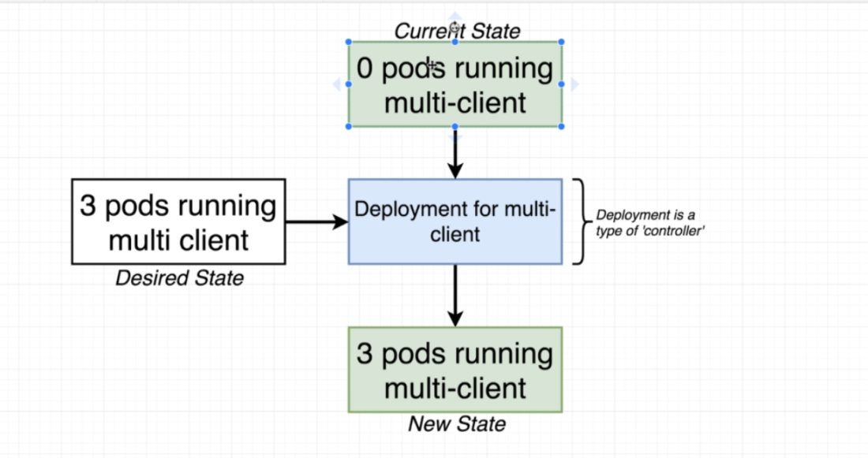

**In short, we use kubernetes when we want to run different types of containers, running in different quantities on multiple different machines.**

1. **Using Kubernetes in Dev vs Production:**

* There is a huge difference between using kubernetes in development environment vs using it in local environment.
* 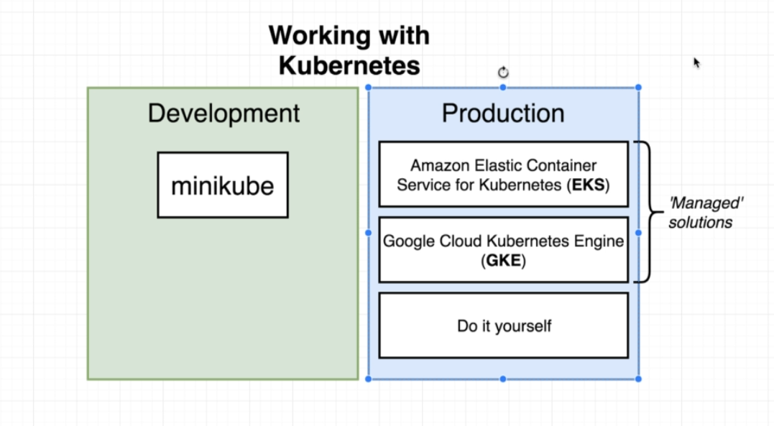

1. **Minikube:**

* Command line tool.
* Sets up kubernetes cluster (nodes + master) on the local computer.
* That is, It creates a virtual machine having containers on our local computer.
* Minikube is a virtual machine running on an embedded Linux Distribution (Buildroot) and comes with the Docker daemon pre-installed.

1. **Managed Solutions:**

* These are used in production.
* These are outside cloud providers.
* They set up kubernetes for us and take care of low level tasks.

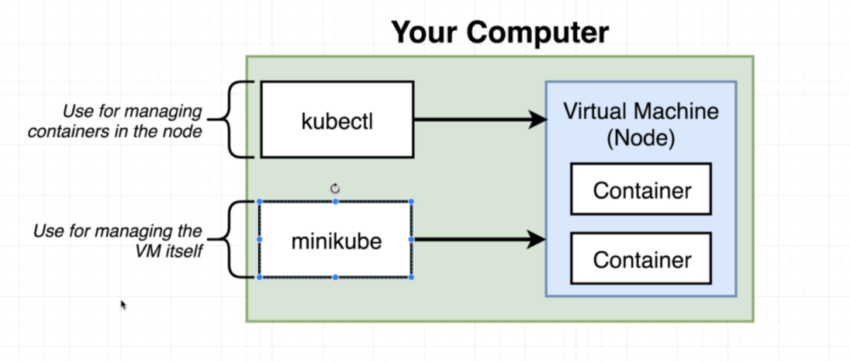

1. **Kubectl:**

* Program to interact with the kubernetes virtual machine created by minikube
* **So minikube creates the kubernetes cluster and kubectl helps to interact with it.**
* **Kubectl is used both locally and in production. Unlike minikube that is used only on local/dev**

1. Installation:

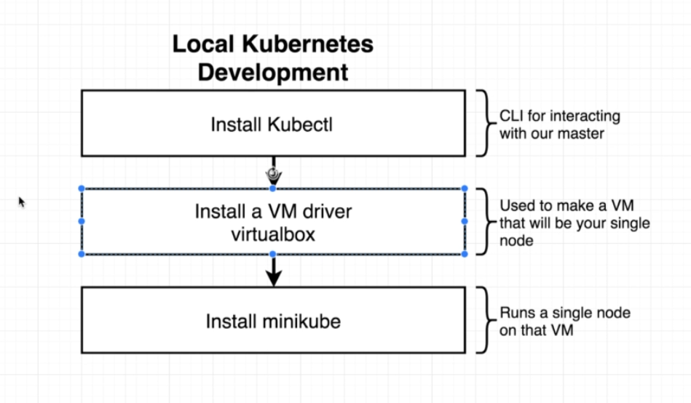

1. **Kubernetes in detail:**

* Moving from Docker-compose to Kubernetes:

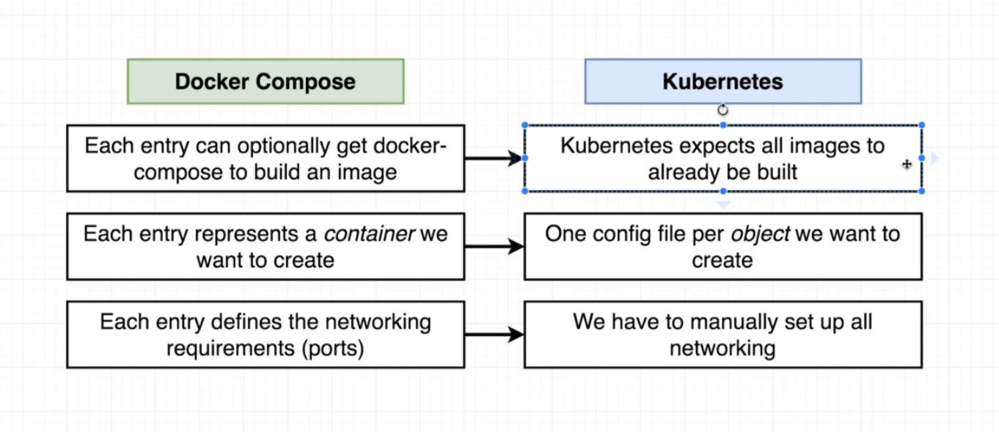

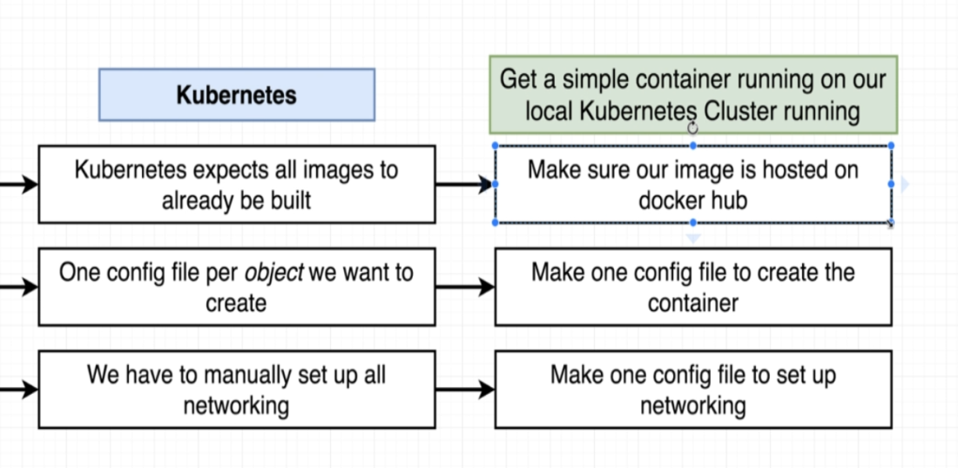

* Steps:

1. Ensure that image is up and running on the docker hub.
2. Create config file.

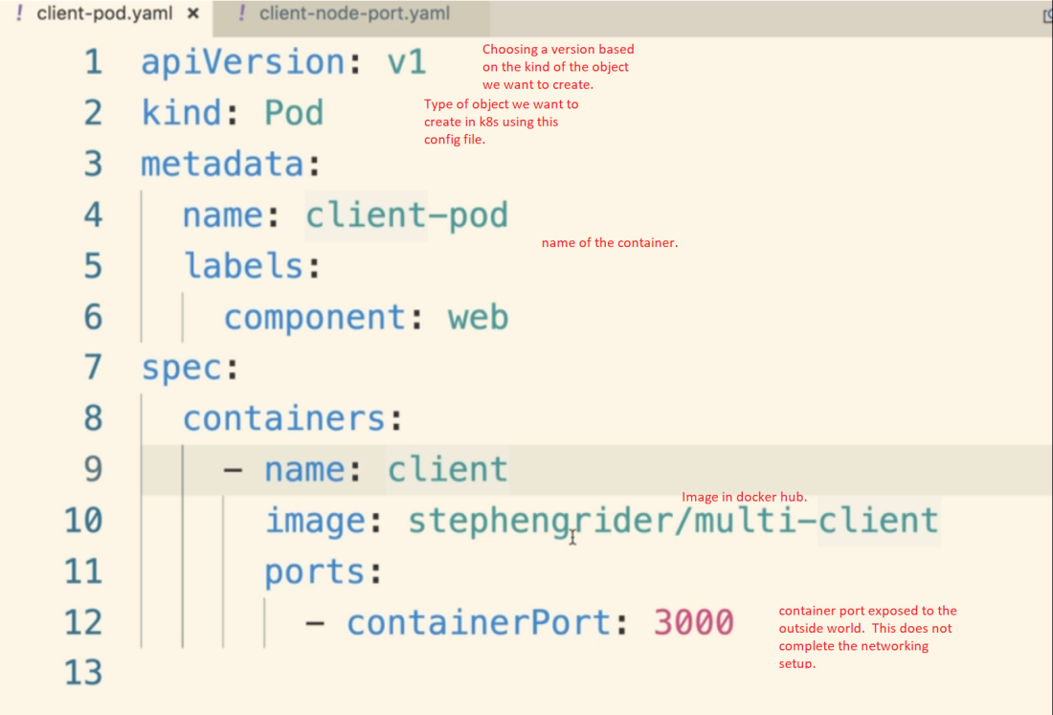

* A config file is not a container but an object. Some object types are below.

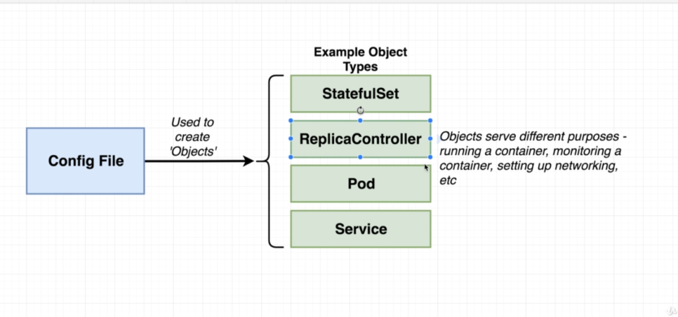

* The 'Kind' field in the config file tells us what kind of 'object' in the diagram above we want to make.

**POD**

* Pod object is used to run one or more containers that are closely related to each other.
* 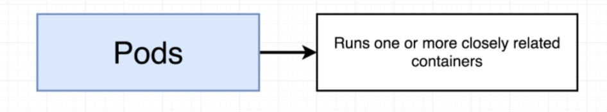
* Service object sets up some kind of networking.
* apiVersion:

based on the apiVersion we can use different types of objects.

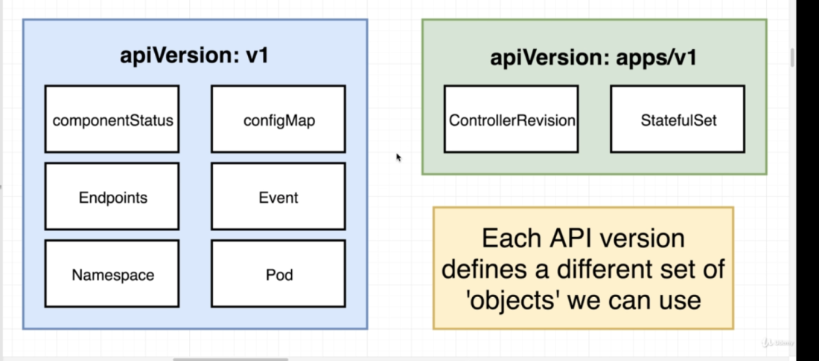

**POD Object:**

* POD is the smallest unit of deployment inside the kubernetes.
* Its an object running inside a Node that has a one or more containers running inside it.
* POD runs inside a Node
* 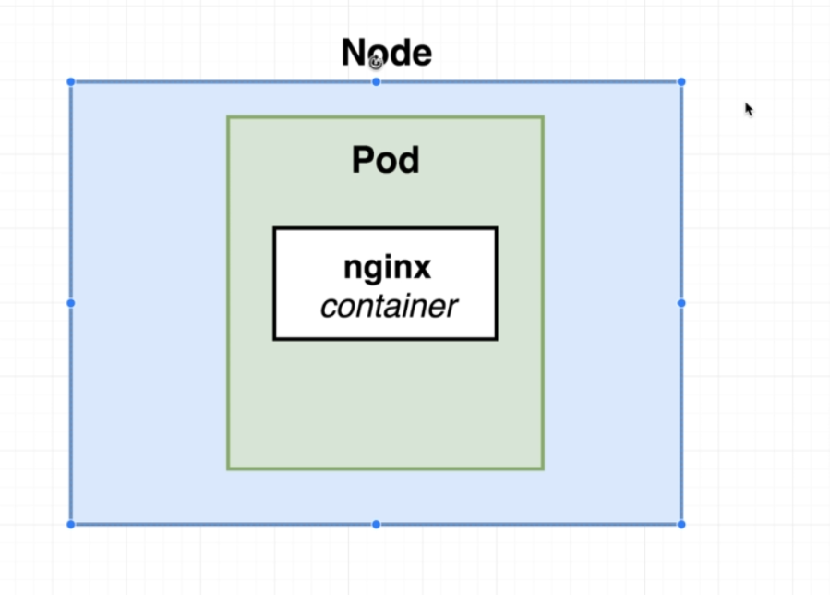
* **A POD is a grouping of containers with a very common purpose that must be running together for our application to be working correctly.**
* In the world of kubernetes we can't create a single container and use it. The smallest thing that we can deploy is a POD (which has containers running inside it).
* 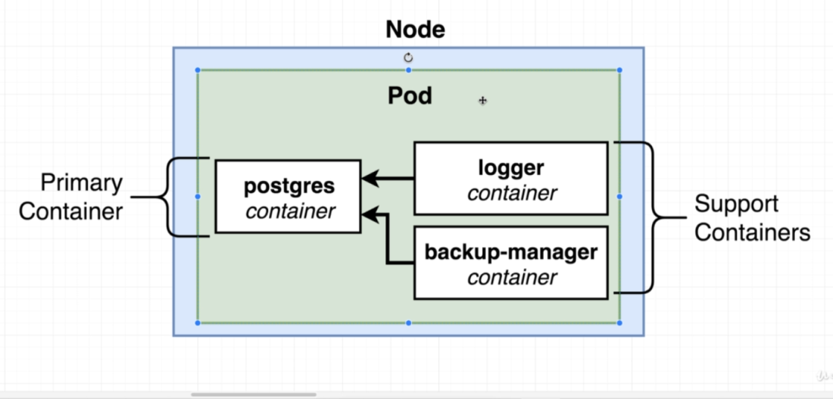
* Here, Logger and Backup manager container as closely integrated to 'postgress' pod. If postgress is down, then logger and backup manager are useless.

* When we delete a container running inside a POD, kubernetes will restart the container it self.

**Services:**

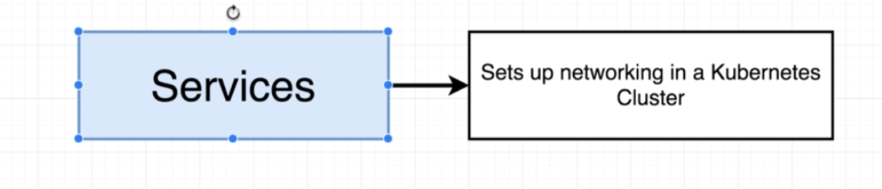

- Used for networking inside the kubernetes.

- Helps to identify which POD we have to access in case of multiple PODs in deployement object.

* Services tries to find every POD which matches its selector
* Each POD has an IP address associated to it. And when a POD is recreated, a new IP address is associated with that new POD. So service also helps to identify the POD with varying IP addresses.

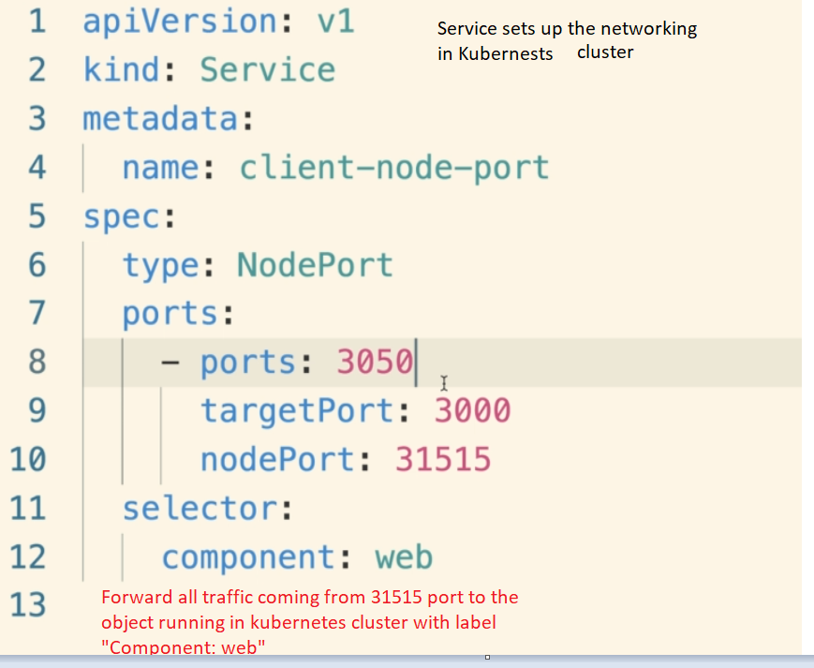

* We need to create a service in order to access any of the container exposed in a POD.

* POD does not have any subtypes.
* Service has 4 subtypes.

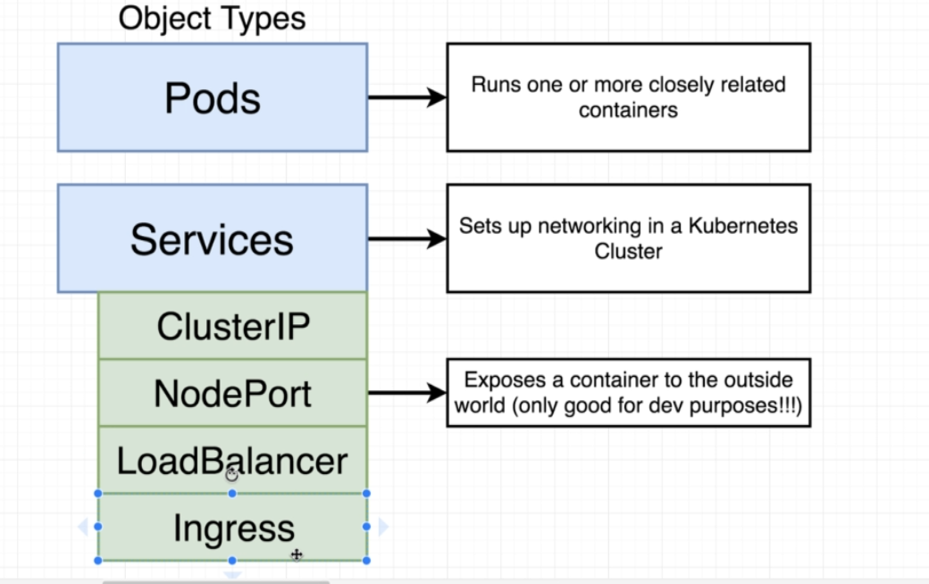

1. **Nodeport**: To expose a container port to the outside world. Only good for development services.

* It creates a communication layer between outside world and the container running inside the POD
* Kubeproxy is a one single window to the outside world.
* Request coming in will pass through the 'kube proxy' which will decide which service should be called.

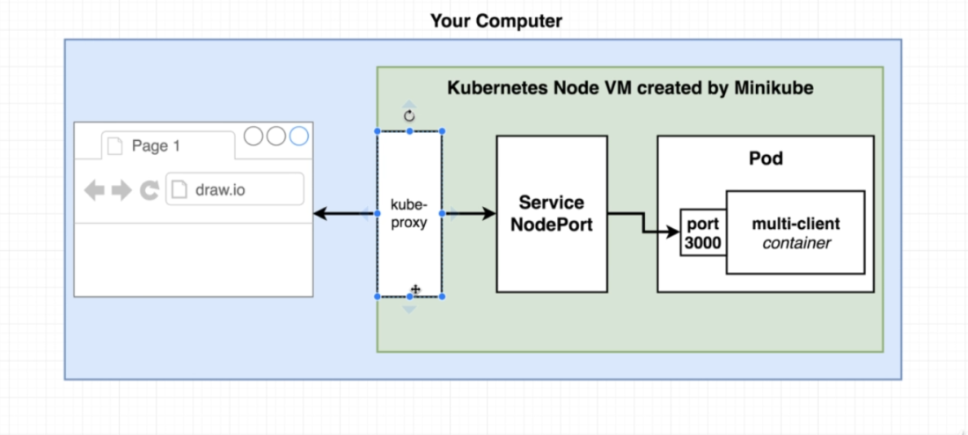

- Label- selector model is used to communicate between POD and service files.

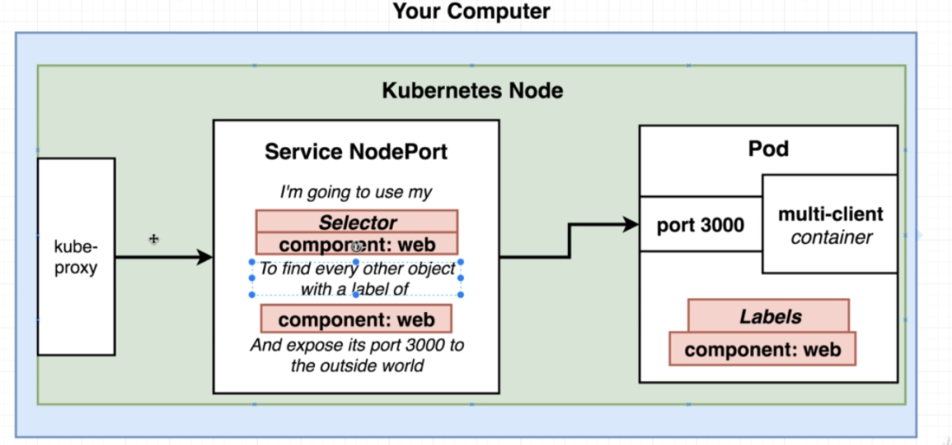

* How the 'ports' field work in the 'Service' config object.

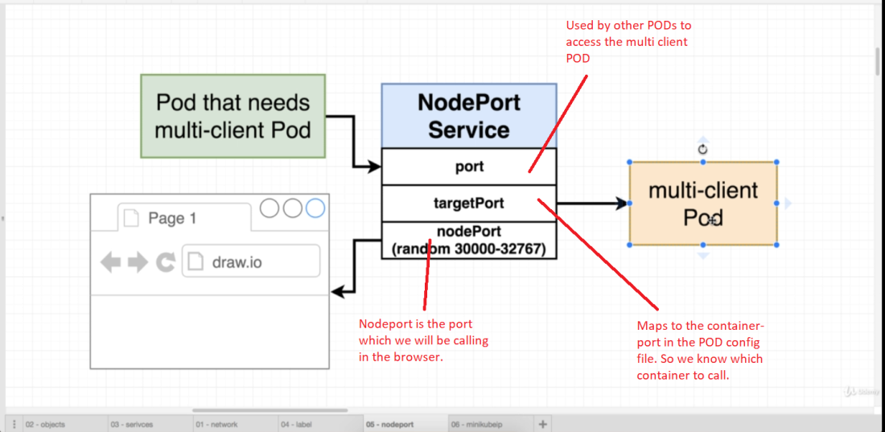

1. **Running containers in Kubernetes:**

* Once we have our config files ready, we can push them to the kubernetes using the kubectl command.
* 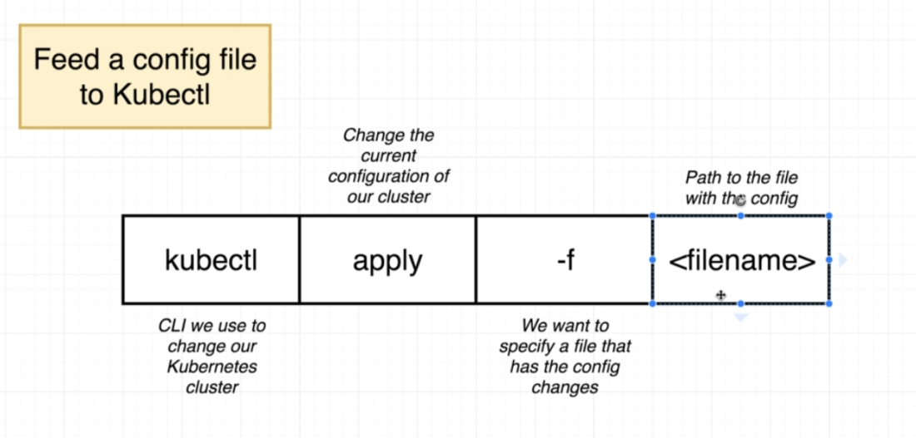
* Output of above program:

For POD

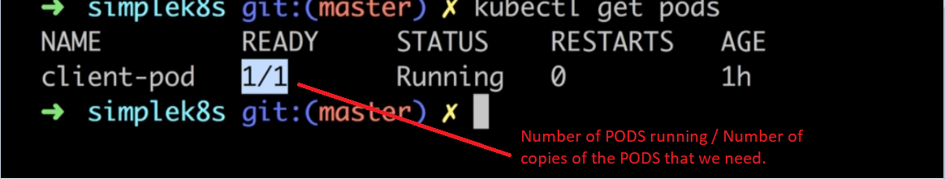

* For Service:

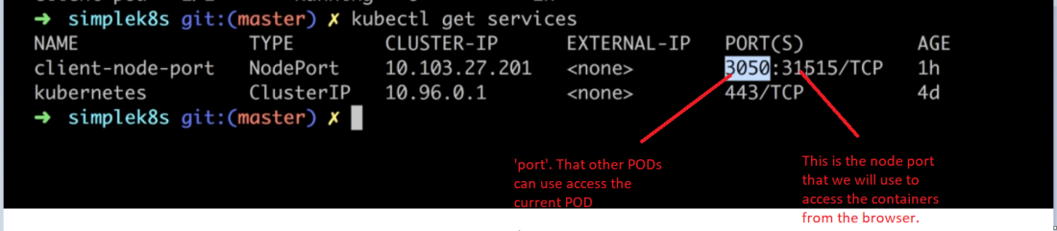

* To get the status of an object in the kubernetes:
* 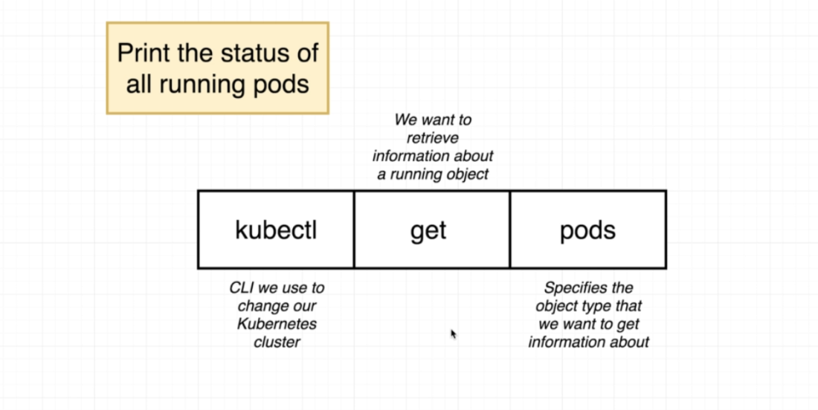
* To access the application running inside the minikube:

<minikube IP>::<nodeport>

Get ip using 'minikube ip' command.

1. **What happens when we send some command to Kubernetes?**

* We send commands to kubernetes only using kubectl command.
* And our interaction is only with the master, which communicates with the Node

Scenario:

* Suppose the application has three containers- 'service', 'client' and 'worker'.
* We need to have 4 containers of 'worker' running.
* So we will feed the config files to master using 'kubectl apply -f <file_name>'
* The master has some applications running on it.
* One of the responsibilities of the master is to continuously poll the nodes and see what is happening.
* 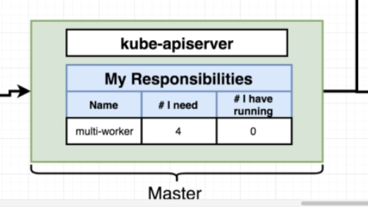
* **So when we ask for 4 containers, master will see that we need 4 but the nodes are not running any containers.**
* So it will tell the nodes to run 4 copies.
* 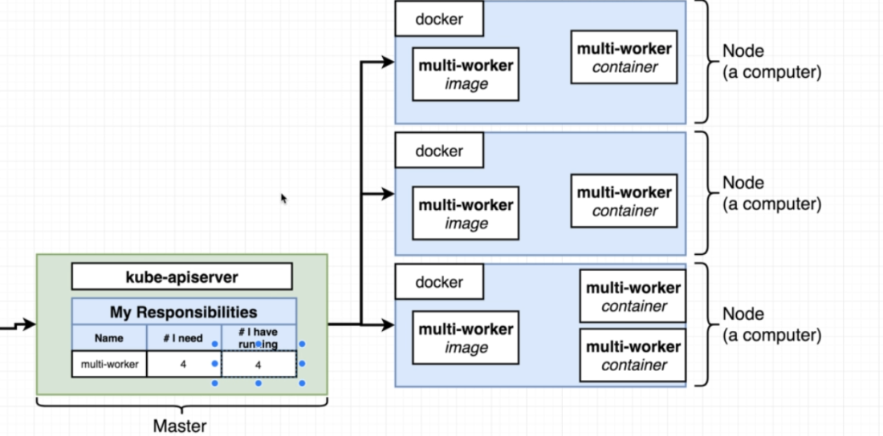
* If any one of the container is down, then master, which is continuously polling the nodes, will see that there is a difference between the desired and actual state.

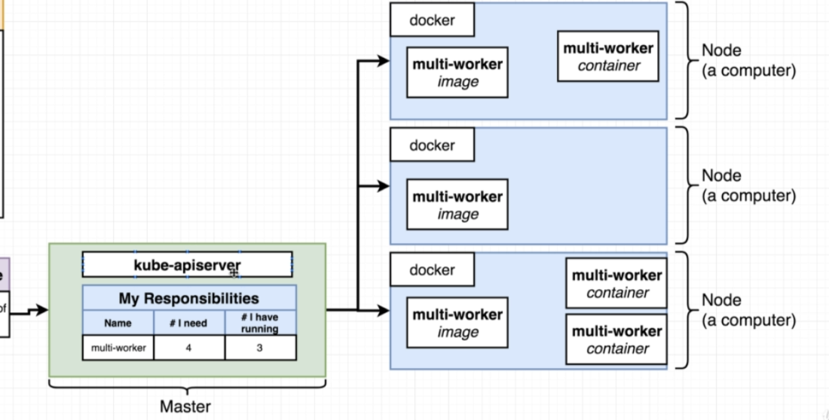

* So master will again create another container to match the desired and actual state.

* 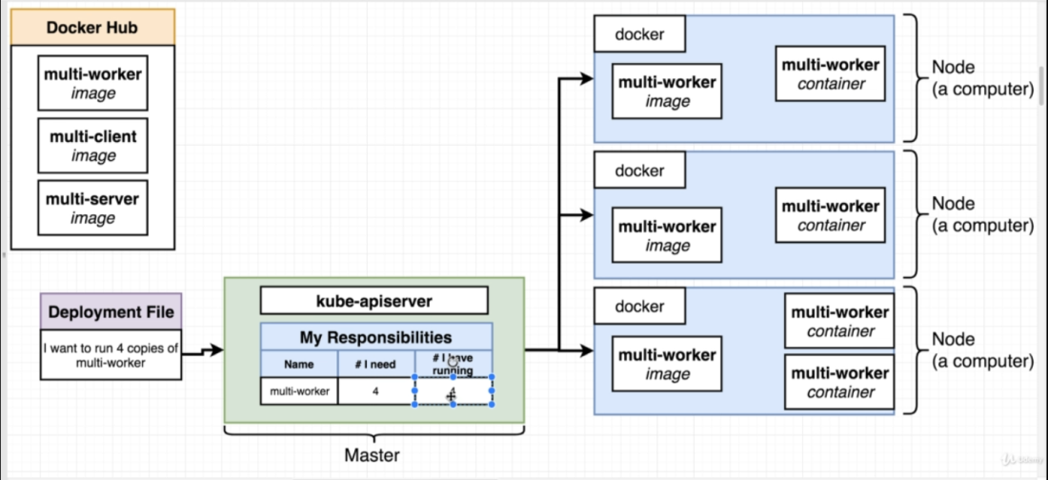

Notes:

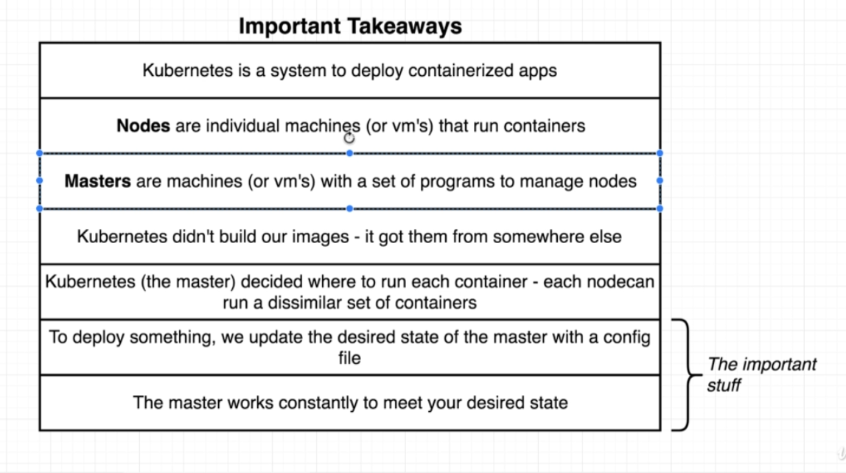

1. Declarative vs Imperative Deployment in Kubernetes. ??

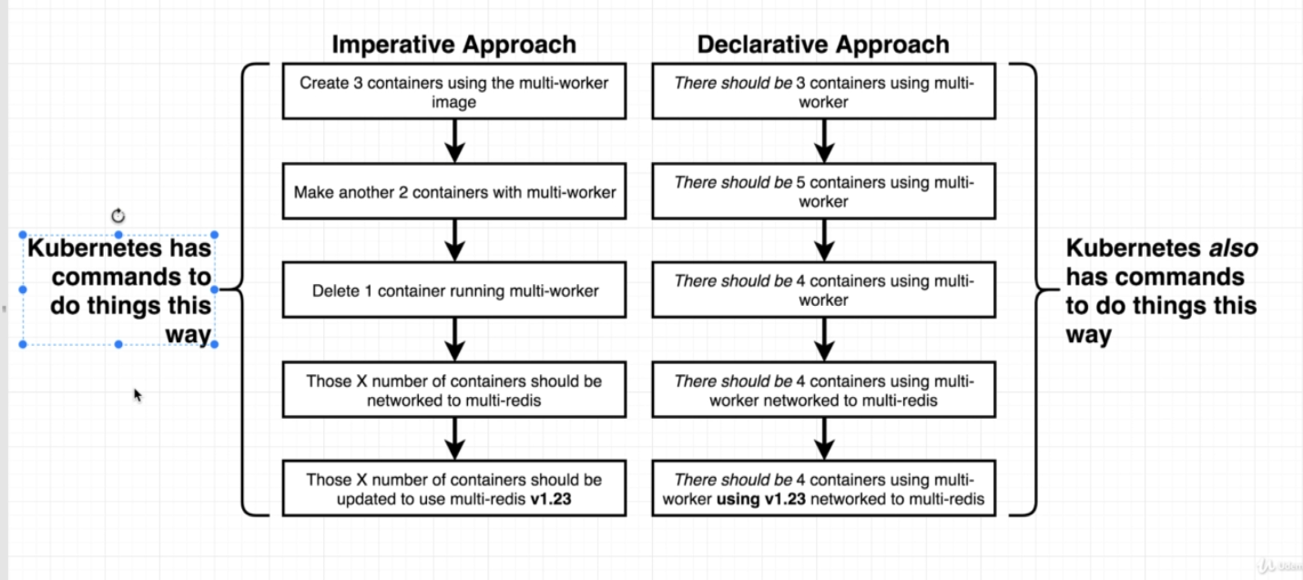

For example, below is the difference in imperative and declarative steps we can use in order to change the image type for a container:

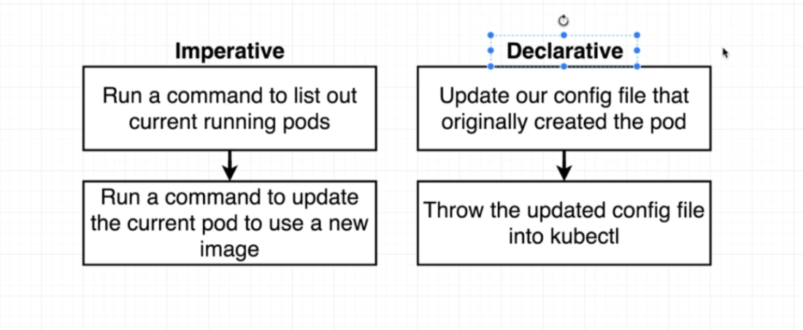

In declarative deployment, we usually update the config file and feed it to kubernetes and let kubernetes do the changes for us.

* Usually when we feed the config file, kubernetes will check the 'Name' and 'kind' fields in the file, if object with same name and kind exists, then kubernetes will not create a new one, but will use the existing one. If there are changes in the config file, k8 will try to apply those changes to the existing object.

* Limitations of Declarative deployments:

We can't update every k8 object.

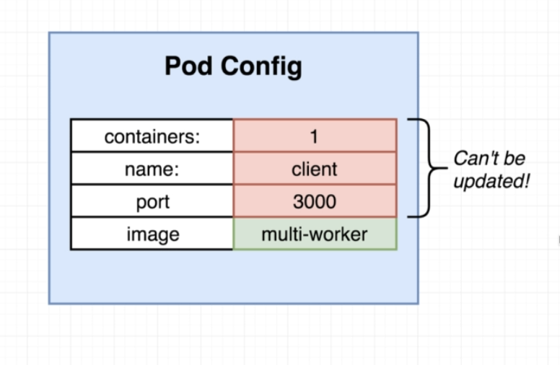

* In order to tackle this problem, we can use a different type of object called 'Deployment'

**DEPLOYMENT:**

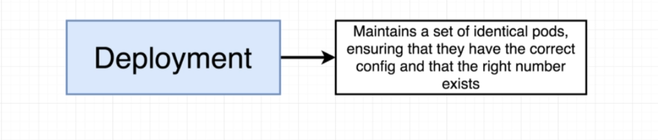

* Object with a set of similar PODs
* Ensures that every single POD in it has correct configuration and its running (not crashing etc).
* POD Vs deployment

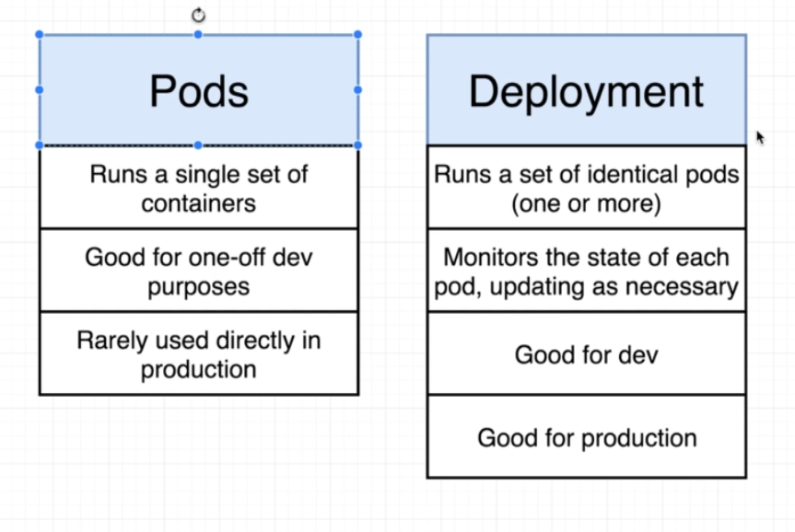

**Important: Unlike POD, with deployment we can change any piece of configuration associated with the object**.

* Deployment Configuration.

Overview:

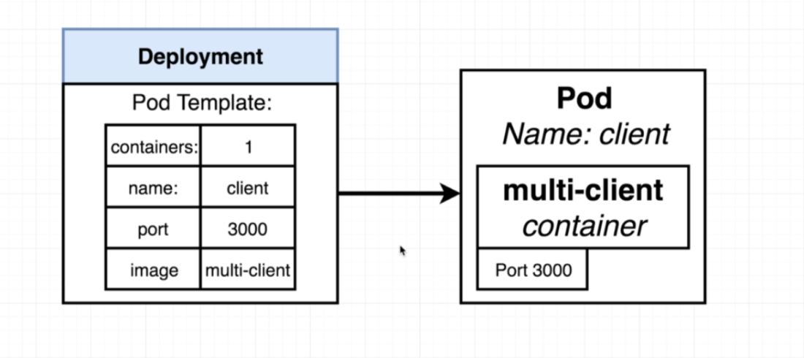

-Config file:

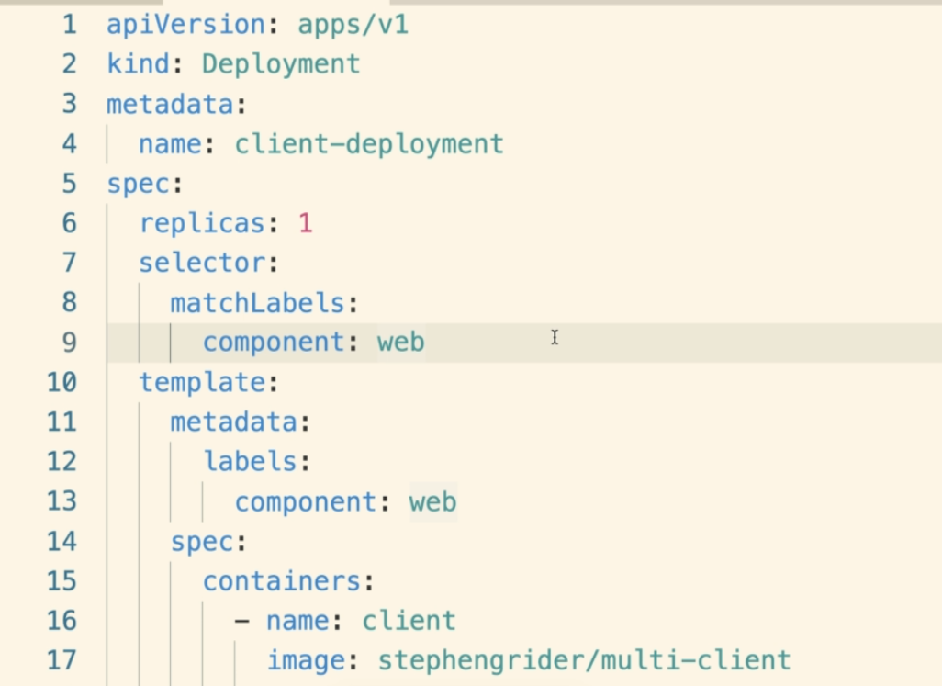

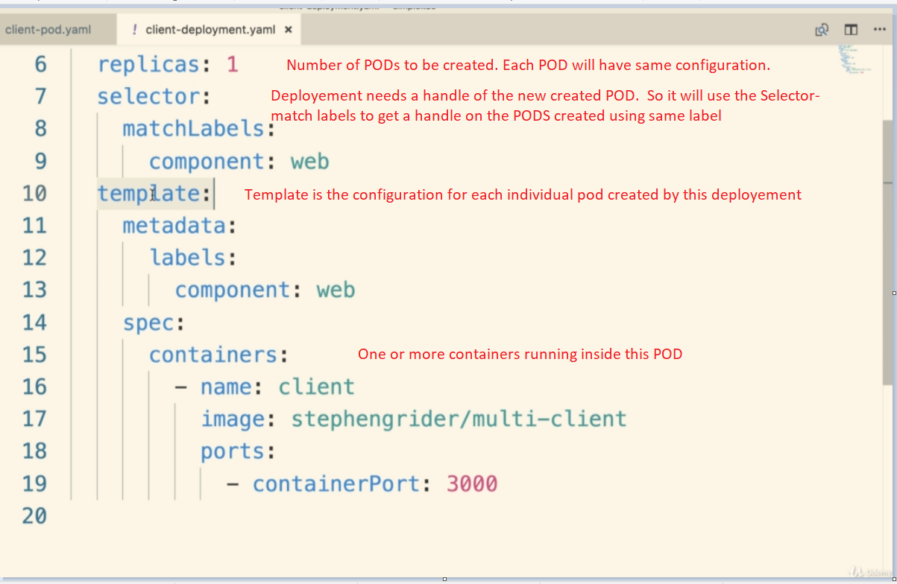

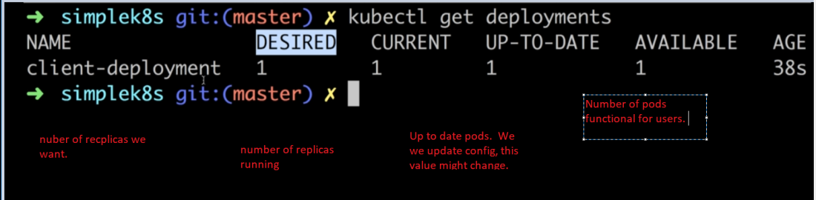

* Ways to have PODs use the updated image from docker.

1. Delete the POD manually. When the POD is deleted, Kubernetes will start it again .

And we can use the latest build.

Deleting PODs is a stupid idea

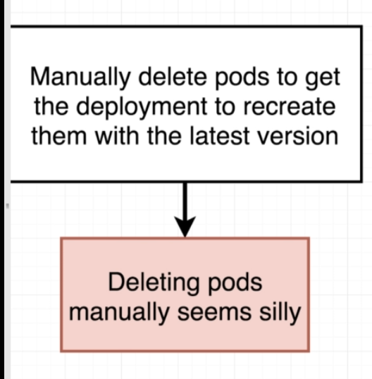

Always create images with build numbers. And also use the same build numbers inside the config files.

So whenever the config is applied again, the change in build number is detected and latest image from docker hub will be used.

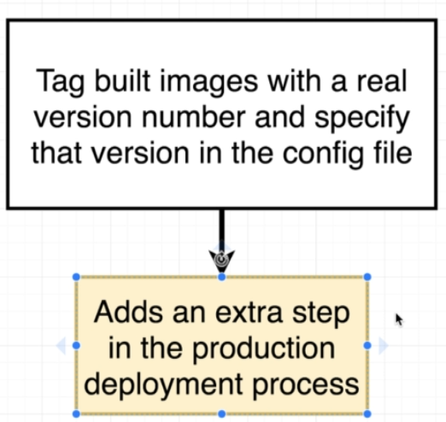

1. Keep creating the image builds with version.

Use imperative commands to tell kubernetes to update to the latest version.

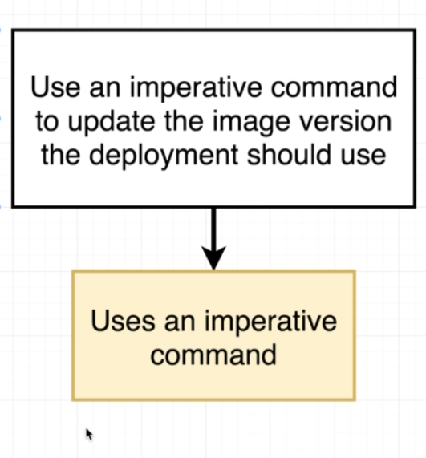

* Imperative image update:

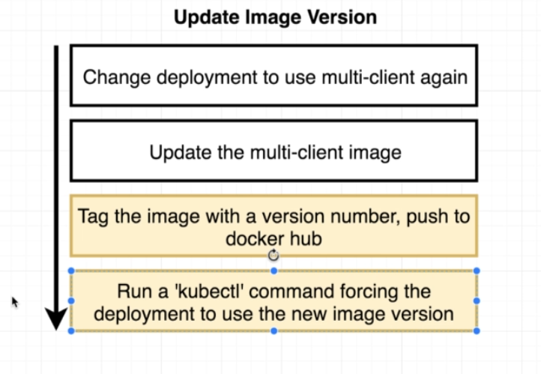

CLUSTERIP SERVICE

* It’s a restrictive form of Networking.
* 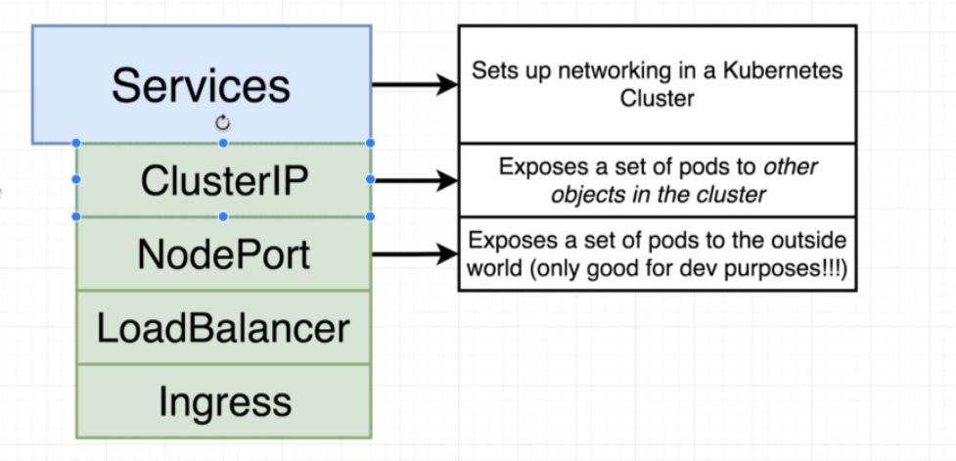
* ClusterIP allows object running inside the cluster to access the object that the cluster IP is pointing it.
* We, form outside, can't access the object.
* 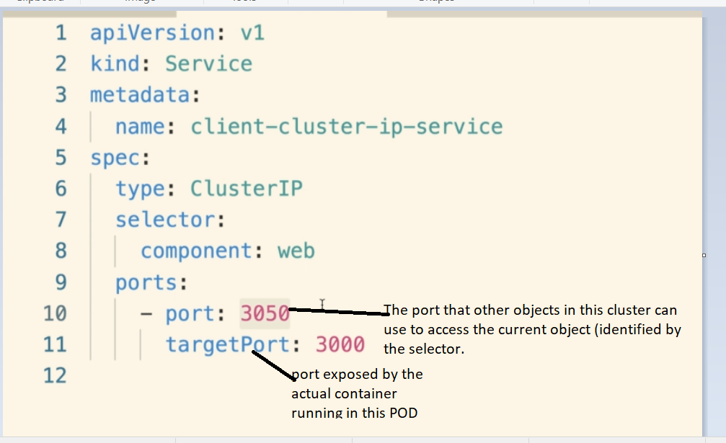

* We can combine multiple config files into one single file but separating them with three underscores between different configs
* A good thing would be to use config file for a deployment and its service in a single file

VOLUMES:

1. Why we need volumes:-

* Suppose we have a postgress container that creates some data.
* When the container is deleted, all the data created by the container is also gone.

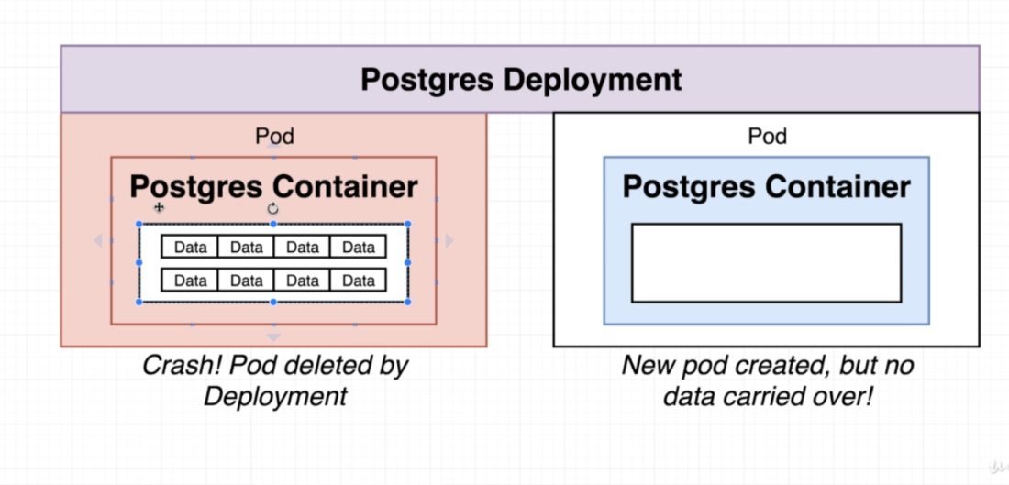

* We can solve this using Volumes
* Using volumes we can have persistent file system that can be accessed by the database container.

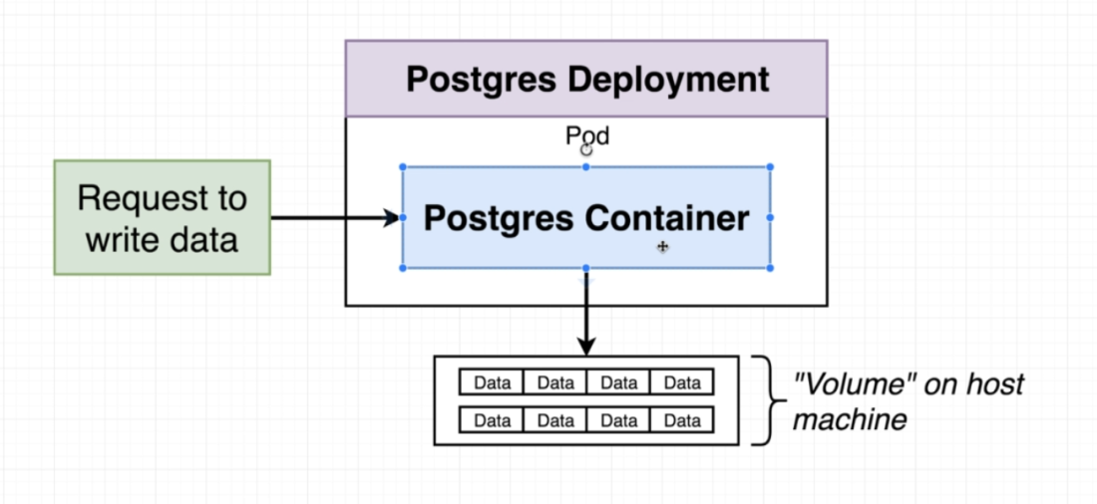

* So the data base won't be writing any data inside the container, but to the file system outside the container.
* And when a Pod is deleted and new one is created then the new Pod gets associated to the same file system to ensure data persistence .

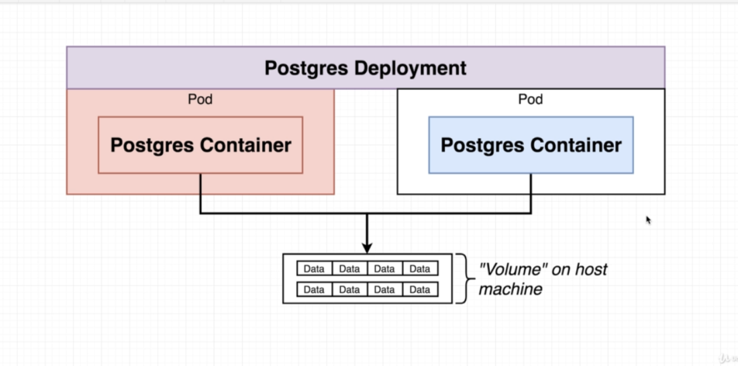

1. VOLUMES in Kubernetes:

* Volumes in Kubernetes vs in Docker:

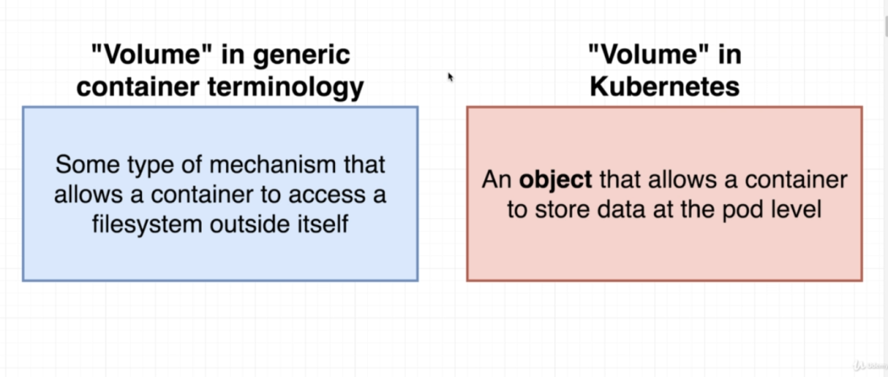



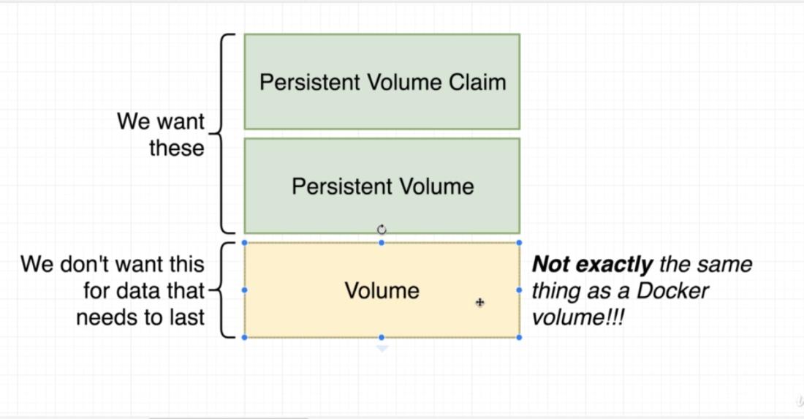

* We can create a config file in Kubernetes to create a volume.
* In Kubernetes, the Volume is data store that belongs to a particular Pod.
* Any container running on that Pod, has access to that data store.
* So if the container is destroyed and recreated, then it will have the access to the same data store.
* But this volume gets deleted if the entire Pod is deleted.
* 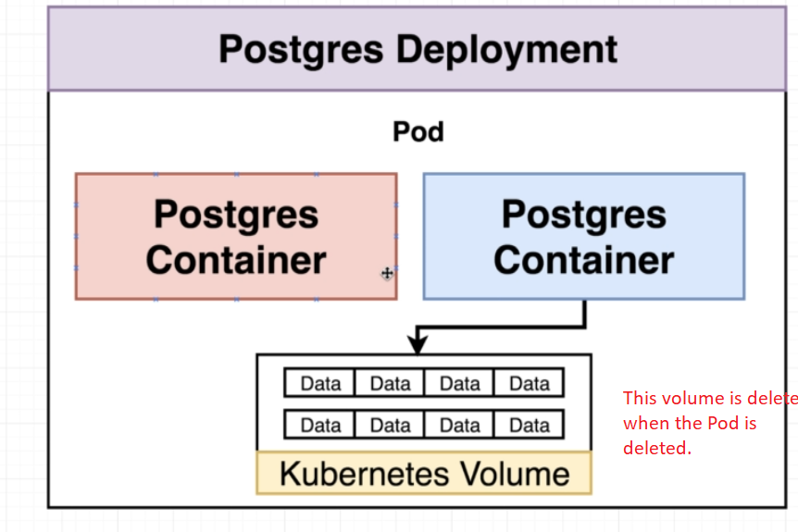
* So we need to use something called as a Persistent Volume Claim

1. Volumes Vs Persistence Volume:

* Persistence volume is not associated with any container or Pod.
* So it remains persisted even if the Pod gets deleted.
* 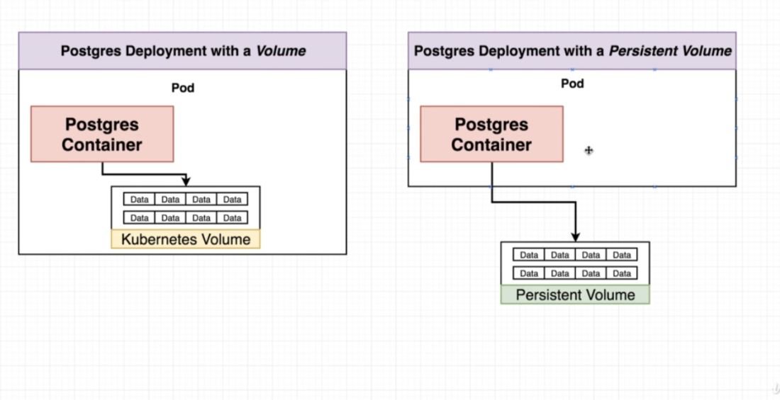

1. Persistence Volume Vs Persistence Volume Claim

* Persistence Volume claim is like an advertisement that allows the Pods to choose form some pre advertised set of volume space.
* 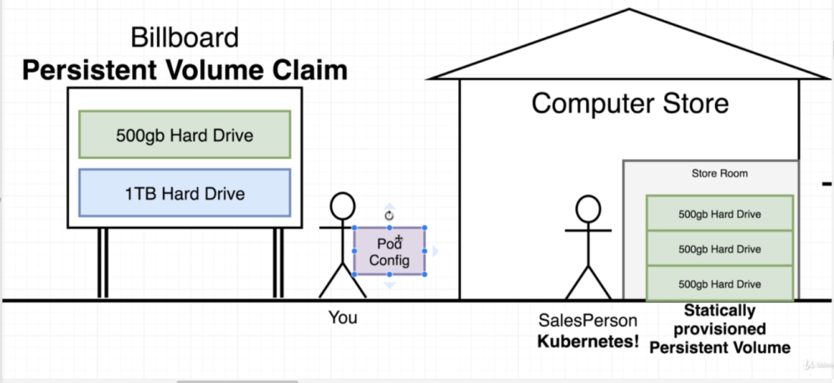

* If K8s does not have the volume that the user asked for, then I will create that Volume on the fly and provide it to the pod.
* Volume claim is not an actual instance of storage.
* We attach the claim to a Pod config.
* This Pod config is then applied to the K8.
* K8 will check the claim and try to find a statically provisioned or a dynamically provisioned volume.

1. Config file for Persistence Volume.

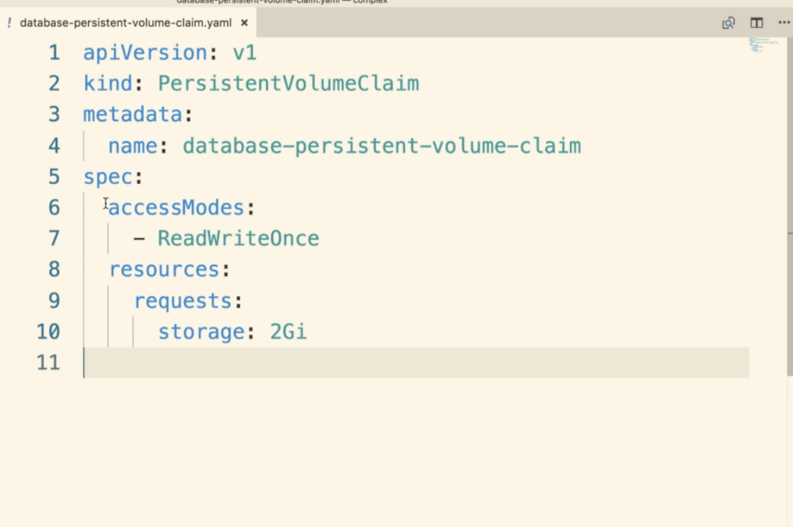

* Access Modes:

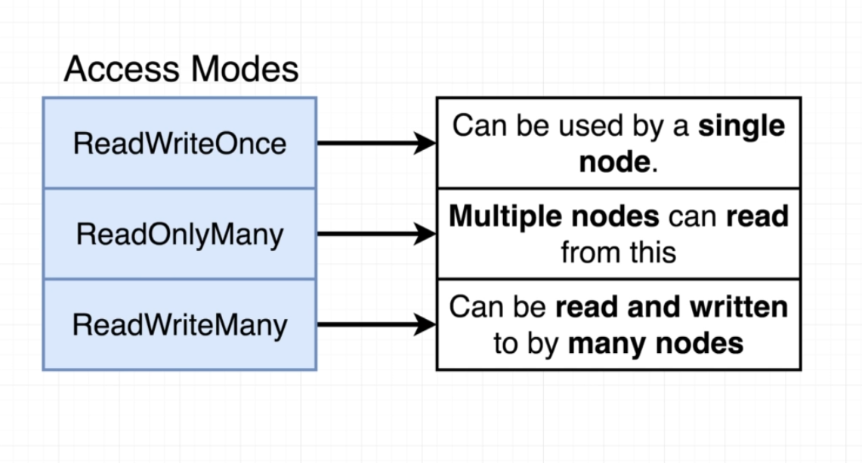

ReadWriteOnce: Only a single node can use this volume (both Read and Write) at a given time

ReadOnlyMany: Many nodes can (only) read the volume at a given time.

ReadWriteMany: Many nodes can both read and write the persistence volume at a given time.

1. StorageClassName

* When we k8s for some amount of storage in our local environment it will take a slice of the storage from the host machine.

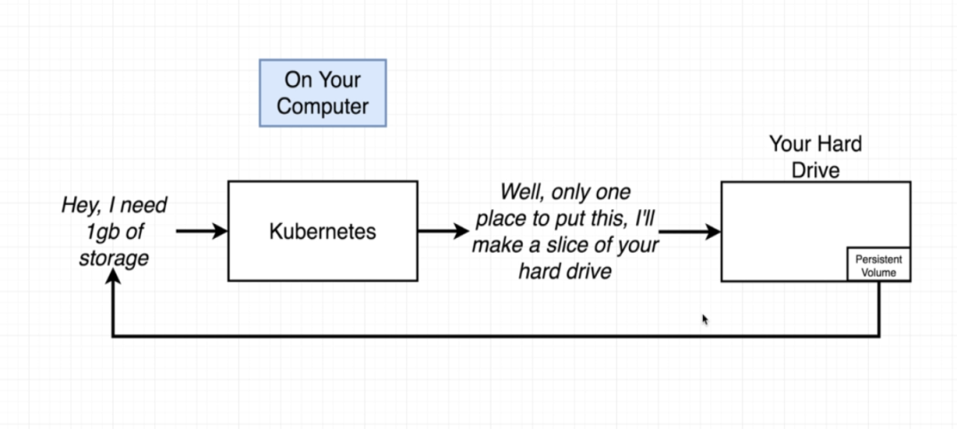

* So in local, it will be using the default minikube host path provisioner

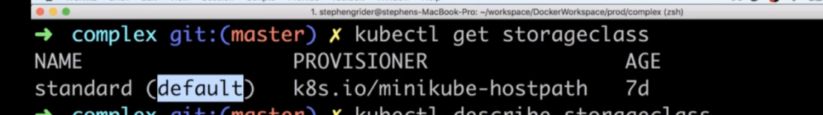

* In case of Production environment where its using some cloud platform, then it will automatically provided for us.

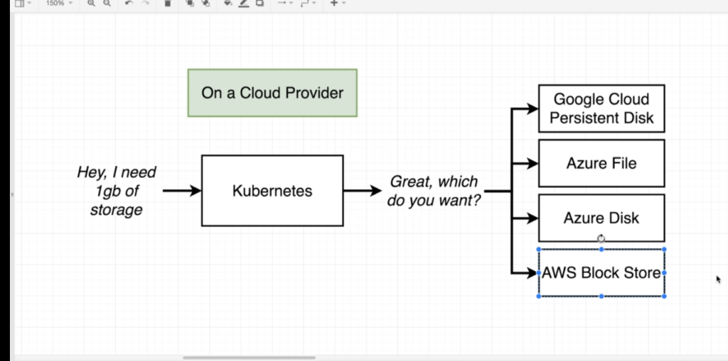

g) Associating Pod to the PVC

* We can do this inside the 'Spec' section of the pod config.
* 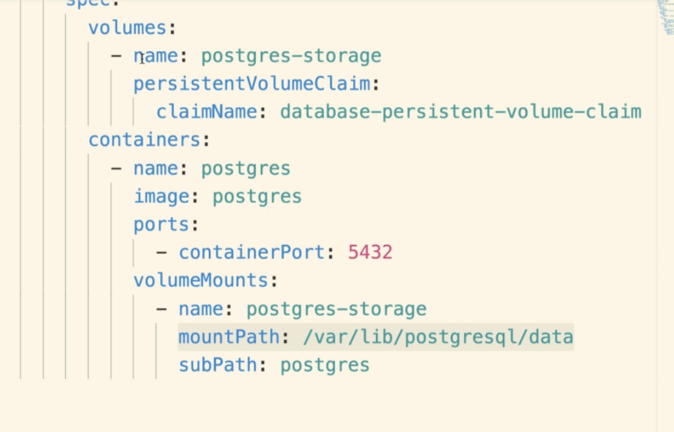

ENVIRONMENT VARIABLES:

1. We can add environment variables using the 'evn' field inside the 'containers' of the 'deployement' 'template'.

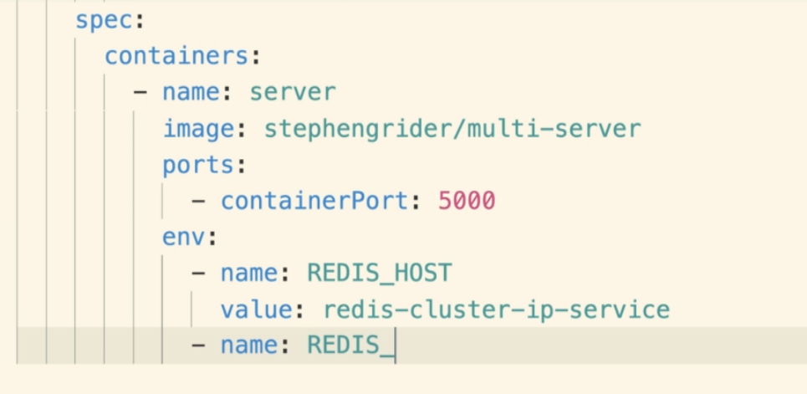

Important: For connection between two different services, we need to provide the host name that will be same as the ClusterIP name.

1. Adding Password env (Confidential data)

* We should not be adding password as plain text.
* We can use the Secret Object for this
* 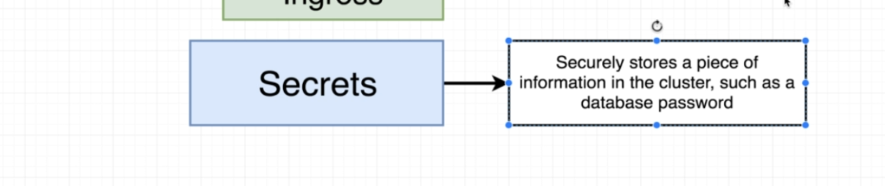
* We can create a config file for a secret or run an imperative command for create one.
* Command:
* 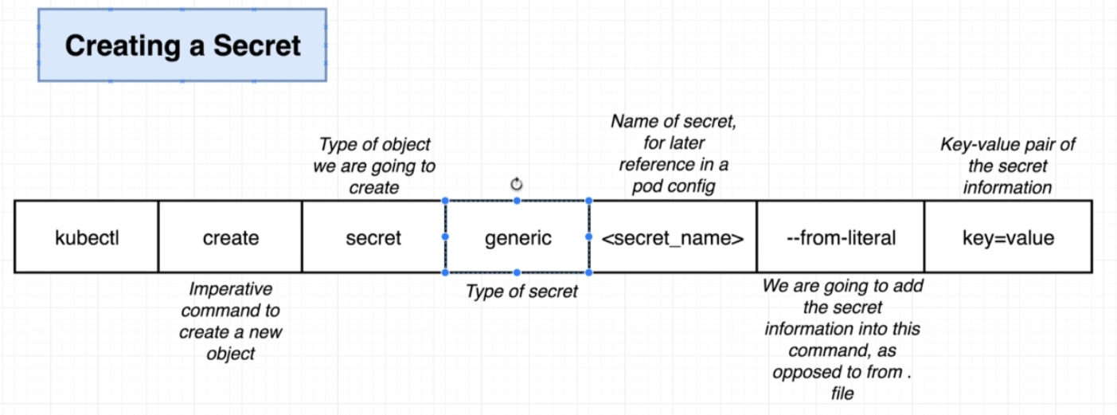

* Generic Type: To save arbitrary number of key value pairs together.
* Secret Name: Will be used to refer the secret in future inside of some pod config.
* --from-literal: We are not reading the secret data from a file, but we will use that in the command line it self.



* Using secrets in the config as env variable:

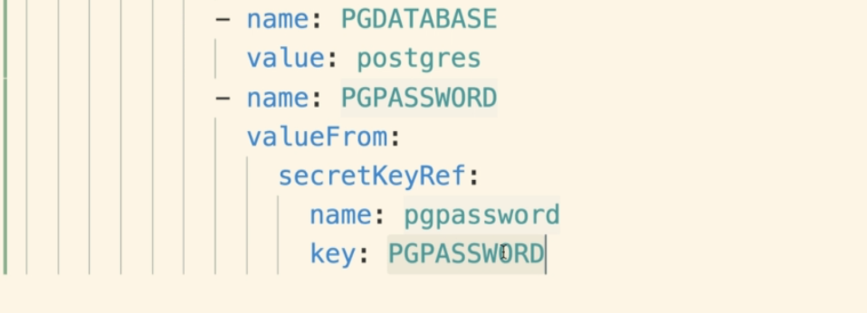

LOAD BALANACER SERVICE:

* A legacy way to get traffic from outside into our application (Ingress is a new and better way to do this).

* 
* We create a config file for create a load balancer with the type of LoadBalancer.
* LoadBalancer only gives access to one set of POD inside the cluster.
* We don't use it anymore.

INGRESS SERVICE:

* 

1. How ingress works?

* In kubernetes a controller is any object that tries to migrate from current state to desired state.
* For example, Deployment object is a controller.
* Similarly we can have Ingress config working as controller.
* 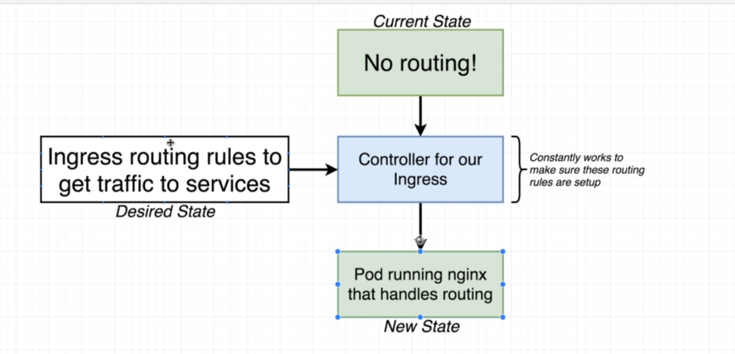

* 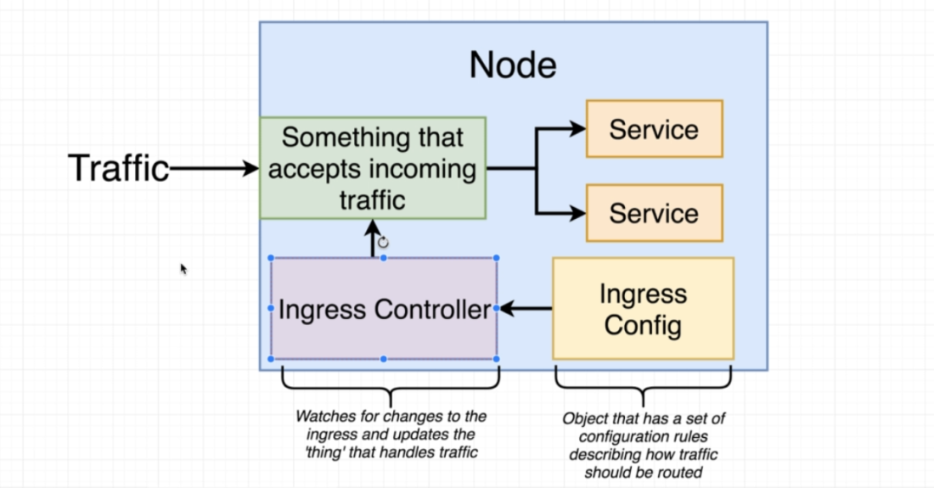s

* 